Typescript is a open source programming language developed by Microsoft that is built on top of Java script by adding static typing. Typescript is wrapper on the java script language. Typescript is java script with extra features that helps to catch error early and make code easier to understand and maintain.
Typescript file has .ts extension. Java script has .js extension. They are compiled down to regular javascript and we can run using browser or nodejs.
In static typing we can use types like Boolean, string, number which we don’t do in Java script. Java script is powerful and flexible but that flexibility can lead to mistake.
Javascript-> We create a function which accepts 2 parameters. We add the number and return it. If we call the function by passing an integer and String still we get the addition result.
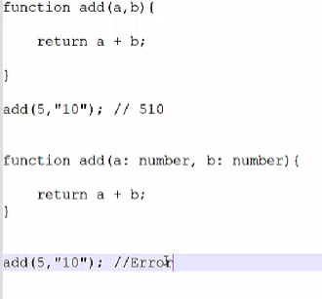
Typescript: If we do the same thing using typescript it will throw an error “Argument of type String is not assignable to parameter of type number”

The good thing is that we will not get this error in runtime but in compile time. Type checking helps to catch bug before runtime.
Prerequisites:
- NodeJS
- Visual Studio Code
- Typescript
- Ts-node
After we install Visual studio code we will also install typescript.
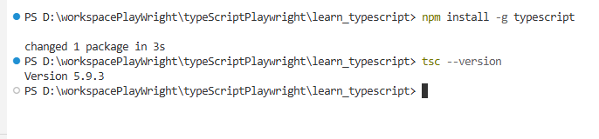
Next we will create a blank folder and drag and drop the same in visual studio code.
After that we will type the command “npm init -y”.
This will create the package.json file. We will add all the dependencies here.
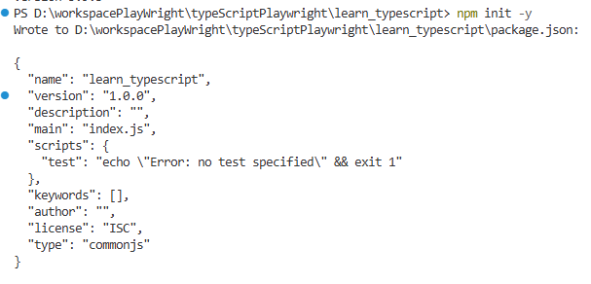
There is one config file that comes with typescript which we need to install. It is called as .tsconfig file. It also comes with json format.
We will enter the command “tsc –init”. We will see the different compiler options here.
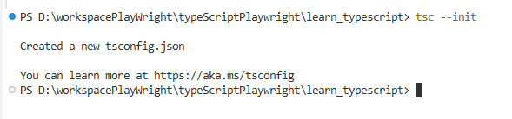
We will make some changes in the config fille.
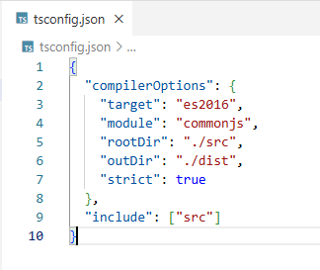
Inside the project we will create a directory and name it as src.
We will create one more directory and name it as dist.
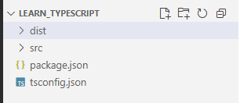
All out typescript files will go inside src. We will create a new file called intro.ts.
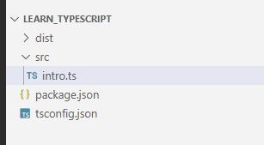
We will copy the earlier code we have written (on add function) and paste it here.
We can execute this code by typing in the terminal npx tsc.
It will compile all the typescript file and will generate a javascript file in the dist folder. We have mentioned in the config file that we will store the output files in the dist folder.
So the typescript file in the src folder gets compiled and converted to javascript and gets stored in dist folder.
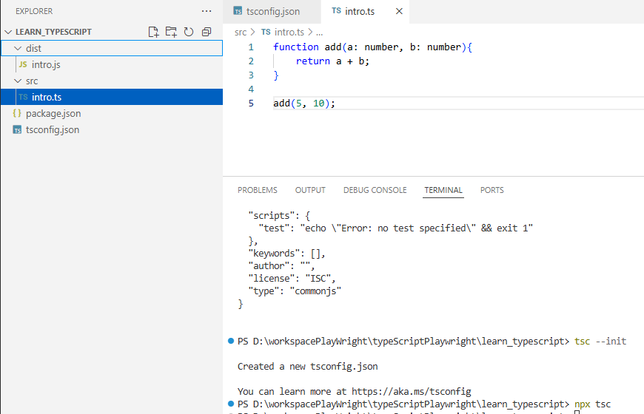
Now we compile the code by typing the command “npx tsc” and then execute the code using the command “node .\dist\intro.js”.
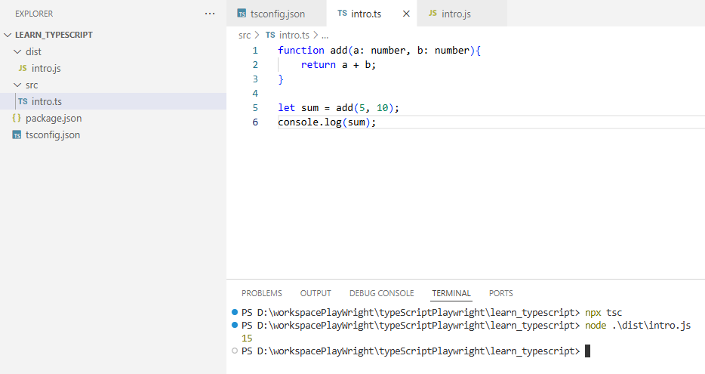
Let us see the intro.js file.
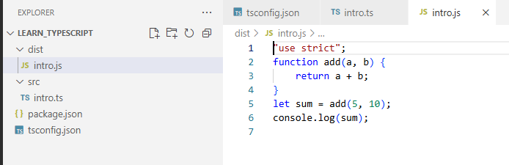
As discussed if we execute the javascript code it will return the result as 510 as it is doing string concatenation.
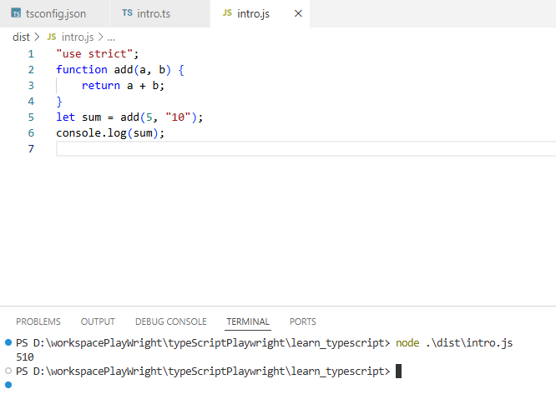
But if we execute the same in typescript it will throw error because both a and b are declared as number. We get a compile time error.
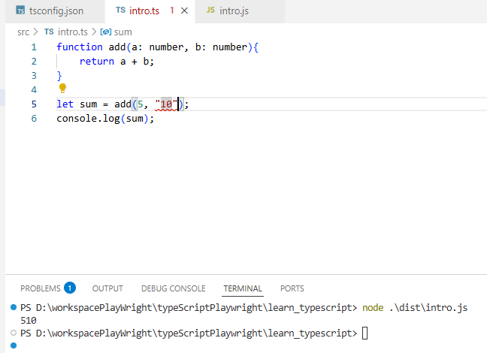
Now we will install the extension “code runner”. It will make our file directly executable. If we don’t want to compile and run every time we can do this. We can simply right click on intro.ts and click on “Run Code”
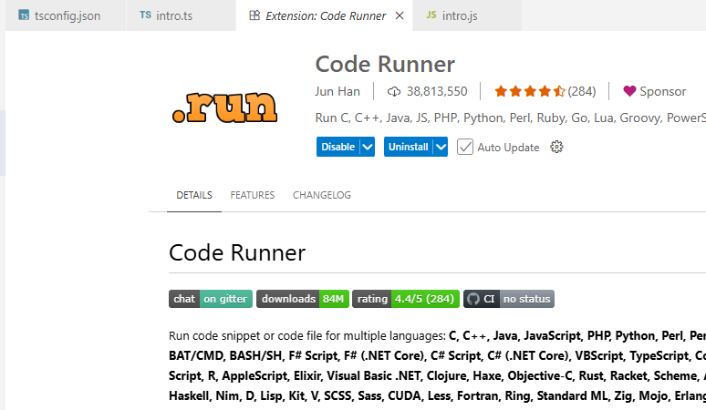
If we want to execute directly via terminal we need to install the package “ts-node”
We can now execute using the command “npx ts-node src/intro.ts”. So we do not need to separately execute and run the typescript file.

